**Donkey vs Elephant**

Cheul Hee (Jason) Yoo & Siyu (Nancy) Nan

**Introduction**

"China!" was one of Trump's most frequently used words throughout his 2016 presidential campaign. He was exasperated that China is killing American companies, precipitating a huge loss of US jobs. His rhetoric seems to have resonated with the US constituents as he has won 2016 presidential election. Of course, Americans did not certainly vote for Trump solely on the ground that he promised to bring jobs back to the States. However, as the United States' economy is still recuperating from the aftermath of the Great Recession (2007 - 2009), a good number of Americans undoubtedly must have found Trump's assurance that jobs are just around the corner irresistible.

Our work focuses on economic legacies of the presidents of the United States (including Barack Obama). Specifically, we analyzed and compared the number of jobs that were created during each presidential term based on his party affiliation (no third party). That said, we primarily used two metrics to measure job creation - unemployment rate and employment level. First, tapping in the dataset publically available on the Bureau of Labor Statistics (BLS) website, we investigated correlations, if any, between the said economic metrics, presidents and their party affiliations. Second, we inspected the result further to see if any partisan difference can be attributed to a party's shrewdness in implementing better policies and etc.

Our study suggests that on the paper Democrat presidents do create more jobs and have better track records of lowering unemployment rates. However, we found that Democrat presidents performed better not because they carried out better economic policies but because they simply lucked out in kindling consumer confidence.

We hope our work brings to light complex relationships between various economic measures and consumer behavior.

**Literature Review**

Many scholars have assessed how well each president performed in his term and made predictions as to how future presidents would fare in comparison. In process, they are often met with two main difficulties. First, the Executive Branch has many responsibilities, including but not limited to maintaining military strength and enforcing federal laws. Therefore, it is fairly difficult to come up with a reasonable standard that appropriately evaluates a president's performance. Furthermore, idiosyncratic differences render predictive models more or less useless. To avoid these problems, in our study, we used party affiliation as the independent variable with job creation being the dependent variable to encapsulate its causal effect on job creation.

Economist Steven Stoft (2016)‘s study shows that Democrat presidents on average performed much better than their counterparts in terms of job creation. During 72 years, with time equally split between two parties from 1944 to 2016, Democrats have created 52 million jobs while Republicans 26 million. Same trend is found in percentage increase. However, Blinder and Watson (2013) shows that this difference is caused, in a nutshell, by luck. They have taken a fair number of factors into account including business cycle, inflation and oil shock etc.

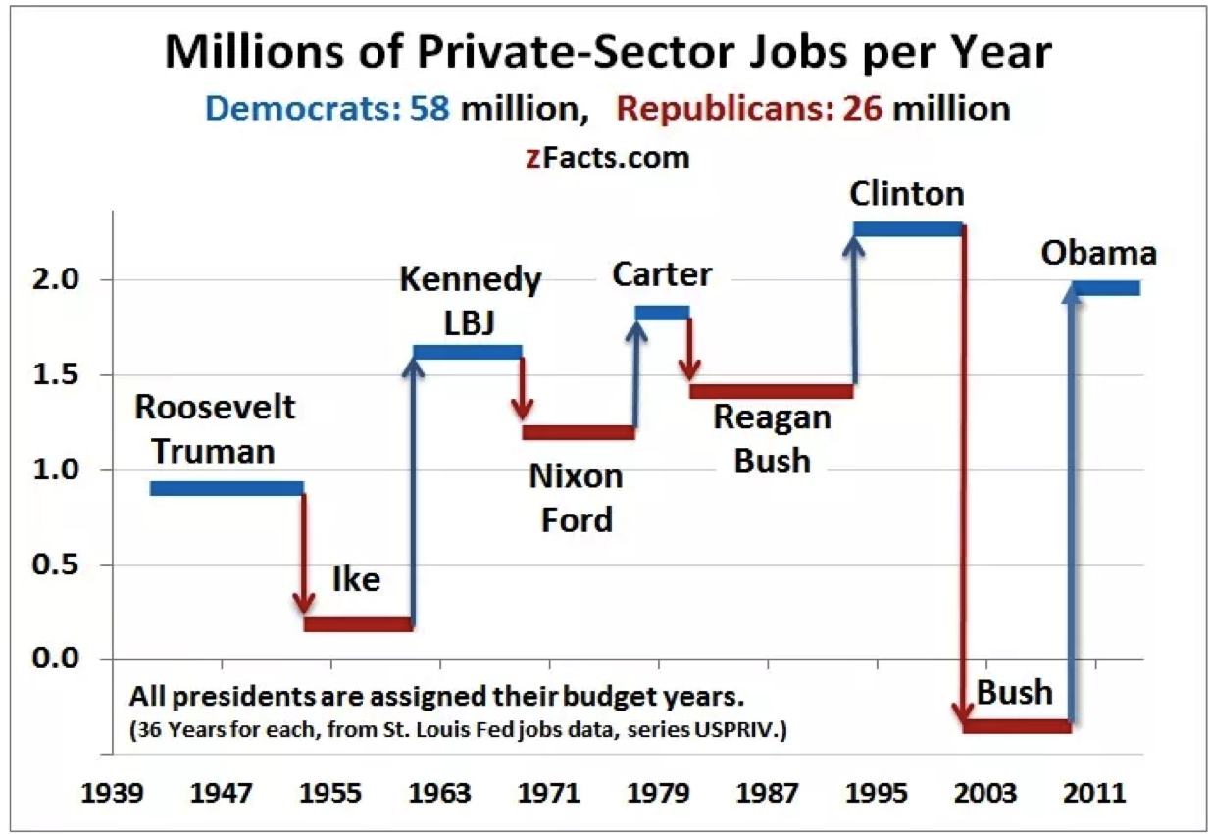

Fig. 1: Steven Stoft ‘s study result

Inspired by Blinder and Watson(2013)’s idea of considering external economic factors, we have decided to separate our factors into two - influences the federal government can induce and domestic or global economic trends that the government can barely curb. Then, we ran correlation analysis between the said factors and job creation. By doing so, we devised our own model that pictures implications one variable has over the others.

**Problem Statement and Data Collection**

For our project, we concentrated on previous presidents from both Democratic and Republic parties, starting from Truman to current Obama administration, as there barely exist any concrete record of labor statistics prior to the Second Industrial Revolution. Our aim was to analyze and compare the number of jobs generated by previous presidents from both Democrat and Republican parties.

To begin with, we aggregated data pertaining to employment level and unemployment rate from the Bureau of Labor Statistics, which provides monthly level of nonfarm payroll employment and nonfarm unemployment rate. In order to examine the effect of presidents and their party affiliations on job creation, we first and foremost partitioned presidential terms according to the party each president belonged to. Although the inauguration day takes place on Jan 20th, a new president's actual influence burgeons on Oct 1st as he/she inherits the previous president's fiscal budget for the first eight to nine months.

It is important to note that annual fiscal budget has a huge implication a president's economic performance. Our government can implement either monetary or fiscal policy to rein in the economy. Both policies can be further broken down into two. In total, there are four strategies that the government can use at its disposal to affect the economy - interest rate, tax rate, money supply and government expenditure. Therefore, adjusting presidential term by making each term starts on October 1st eliminated "unfairness". This contribute to a stronger result.

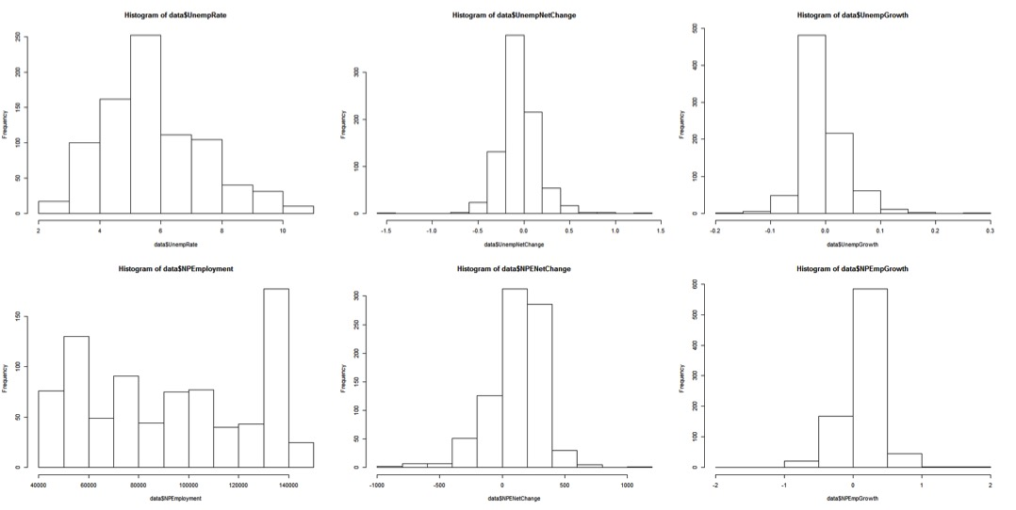

Fig. 2: Data distribution graph of unemployment rate, net change and growth rate; Nonfarm Payroll employment number, net change and growth

We included M2, government expenditure and federal fund interest rate in our study as factors that our government has control over. Tax is not included as individuals pay different rates based on their incomes and using the median tax rate does no justice in accurately encapsulating how much impact raising or lower tax rates has on the economy. M2 is used as a measurement of money supply, including but not limited to checking deposit, saving deposit, mutual funds and other time deposit. Government can also increase its expenditure in order to create more government-related jobs such as increasing police force. It can also lower federal fund interest rate to encourage companies and banks to borrow more money. BLS also provides data pertaining to productivity level starting from 1947 to 2016 on quarterly basis. Lately, we transformed recession into a binary attribute. https://lh5.googleusercontent.com/TwZS5yw1uiQRE18DcGoX-l6jpXiWpb6utKCwN6M2BbraS2rBgY9HkZ5IN4Gs1yE0PPD19BdXhN14x4GTRnT0ul2qFYwNbRaSkCYlHrk24IqCokKHciEFFzXPAQ_nTpmWPI6-7iFu

Fig. 3: Example of Data sheet- each row is a year and each column a different attribute.

Furthermore, with all factors considered and the results we attained, we built a regression model to predict employment climate in the next four years.

**Results**

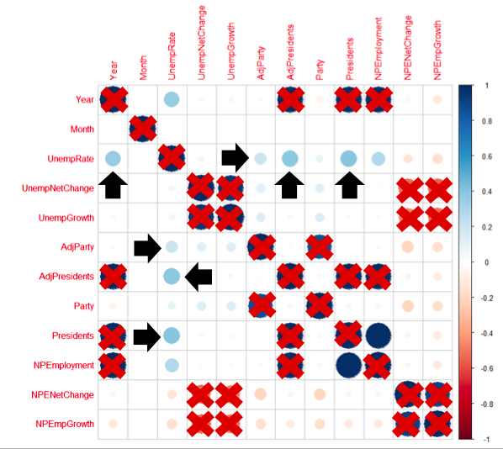

Fig. 4: Correlation visual graph of employment, president and party

The first thing we tried is doing correlation analysis of "Adjusted Party," "Presidents" and "Employment level," and "Unemployment Rate." From the result we get, unemployment rate is growing by years, from Truman’s term average 4.24 to Obama’s term average 7.47. Attribute ‘President’ shows a stronger correlation with unemployment rate than Attribute ‘party’, which suggest that it is how individual president perform that precisely correlates with employment situation, not party. We also attained from the graph that correlation was stronger with adjusted party and president than with the unadjusted measurements. This suggests rationality of our adjustment. This analysis generally gives us the idea that on the one hand, president is weakly correlated with unemployment situation. On the other hand, it insinuates that we were correct in adjusting party and presidential terms in our detail analysis.

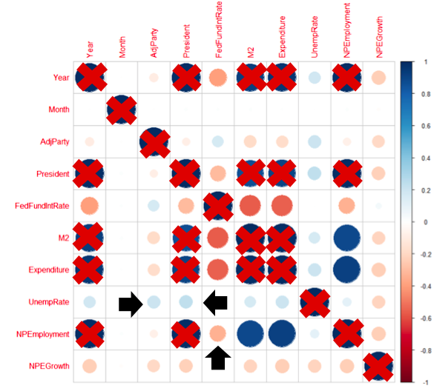

Fig. 5: Correlation visual graph of M2, expenditure, interest rate and president, party

With the basic idea of preliminary analysis, we analyzed on the correlations among "M2", "interest rate", "government expenditure", "adjusted president" and "adjusted party". Nothing stands out in this analysis. M2, interest rate and government expenditure all have very weak correlations with unemployment rate.

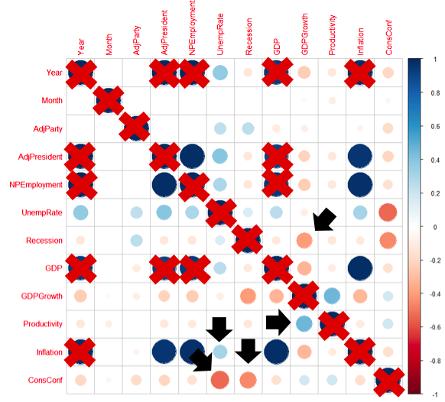

Fig. 6: Correlation visual graph of recession, consumer confidence, productivity and president, party



Fig. 7: Pattern we got from correlation analysis

After only unearthing uninteresting patterns, we shifted our attention to the untamable global or domestic trends. Here, we witness two interesting patterns. Consumer confidence has a strong negative correlation with unemployment rate and recession. They have the greatest absolute value of correlation we have seen so far in our analysis. However, recession does not have a strong negative correlation with unemployment rate. That is to say, recession is strongly affected by or has a strong effect on consumer confidence whereas consumer confidence is strongly affected by or has a sharp effect on unemployment rate, as shown in figure 7. Although we cannot identify which one initially instigated the cycle, it is evident that they interact with one another. We conclude from here that the real pattern matter to jobs is recession - consumer confidence - jobs.

Going back to the preliminary analysis that president is more correlated with unemployment rate than party is, we did a two-sided hypothesis test of party - job creation. The hypothesis test gives 95% confidence that Democrats, on average, create more jobs. However with correlation analysis in our studies, we can conclude that it is not the party affiliation which contributes to the difference. It is the economic factors such as recession and consumer confidence that affect job growth.

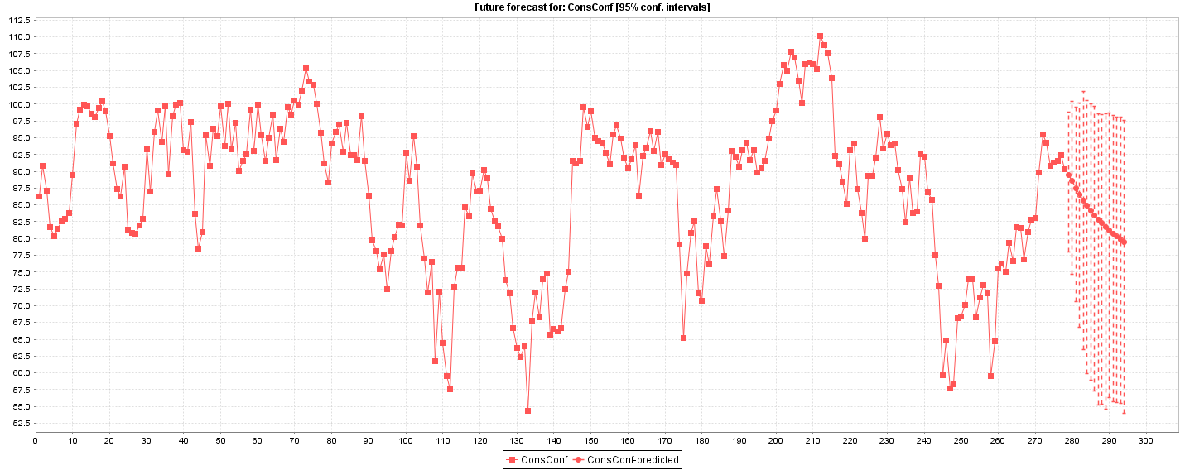

Fig. 8: Consumer confidence for the next 4 years.

Using the data we have gathered, we have built a predictive model using Weka's forecast function. It uses "lagged variables" in conjunction with linear regression to forecast how a variable would turn out in a fixed period.

As shown above, the model predicts that consumer confidence would drop gradually for the next four years and as a result, unemployment rate is apparently predicted to increase.

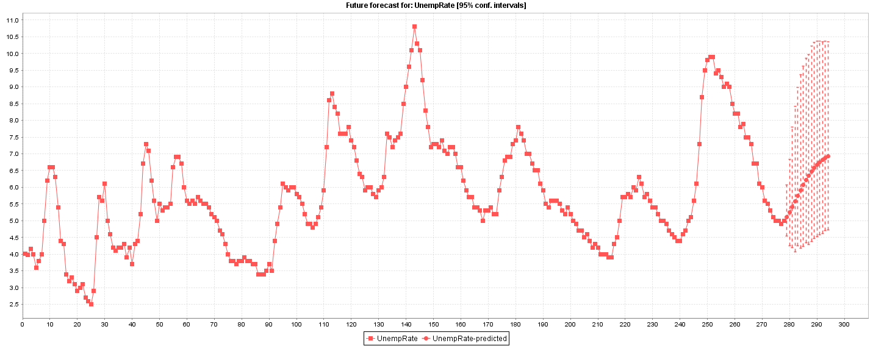

Fig. 9: Unemployment rate for the next 4 years.

**Conclusion and Remaining Work**

With analysis in our study, we conclude that the government can implement many seemingly practical policies. However, they all have fail to create more jobs as they barely have any lasting implication on the economy. In fact, it is consumer confidence and recession cycle that have the stronger impact on job creation. It is by sheer luck that somehow Democrat presidents so far made consumer more confident. It is also purely a coincidence that Democrat presidents were in the oval office when the economic environment was better.